

Software Requirements Specification Document
Quantitative Plant Genetics Simulation Application

Version 1.0
February 10, 2006

CPSC 319
Team 7

UBC Botanical Garden and Centre for Plan Research

Dr. Andrew Riseman




Table of Contents
1 Introduction 1
1.1 Purpose 1
1.2 Scope 1
1.2.1 Name of the software product 1
1.2.2 Summary of the software and its functions 1
1.2.3 Application of the software 1
1.3 Definitions, Acronyms, and Abbreviations 2
1.4 References 3
1.5 Overview 3
2. The Overall Description 4
2.1 Product Perspective 4
2.2 Product Functions 5
2.2.1 User Functions 6
2.2.2 Administrator Functions 6
2.2.3 Professor Functions 6
2.2.4 TA Functions 7
2.2.5 Student Functions 7
2.3 User Characteristics 7
2.4 Constraints 8
2.4.1 Hardware limitations 8
2.4.2 Software Limitations 8
2.4.3 Parallel Operations 8
2.4.4 Audit functions 8
2.4.5 Reliability Requirements 8
2.4.6 Safety and Security considerations 8
2.5 Assumptions and Dependencies 8
3. Specific Requirements 9
3.1 External Interfaces 9
3.1.1 Administrator, Professor, TA, Student Interfaces 9
3.1.2 Administrator, Professor, TA Interfaces 13
3.1.3 Administrator, Professor Interfaces 14
3.1.4 Administrator Interfaces 19
3.1.5 Student Interfaces 19
3.2 Functions 23
3.2.1 Administrator, Professor, TA, Student Functions 23
3.2.2 Administrator, Professor Functions 25
3.2.3 Administrator, Professor, TA Functions 38
3.2.4 Student Functions 40
3.3 Performance Requirements 42
3.4 Logical Database Requirements 43
3.5 Software System Attributes 44
3.5.1 Reliability 44
3.5.2 Availability 44
3.5.3 Security 44
3.5.4 Maintainability 44
3.5.5 Portability 44
4. Change Management Process 45
5. Document Approvals 46
6. Supporting Information 47
6.1 Client Proposal 47
6.2 Sample Lecture Slides (Quantitative Genetics) 50

1 Introduction

1.1 Purpose
The purpose of this SRS is to identify the specifications and requirements of the product outlined in section 1.2. The intended audiences are the client, Dr. Andrew Riseman (Assistant Professor, University of British Columbia Botanical Garden Center) and the members of the software engineering group, Team 7.

1.2 Scope

1.2.1 Name of the software product
The name of the application will be “XGene 360”.

1.2.2 Summary of the software and its functions
The application will simulate plant breeding between diploid plants of the same species under similar environment conditions, employing basic concepts and principles of plant breeding and quantitative genetics. A user of the application will be able to login to the application and view a list of selected problems. An administrator will have full access to all professor functions and all accounts. A professor will be able to create courses, professors, TAs and students. A professor will be able to generate a unique problem for each student user by specifying the mean, standard deviation, heritability factor and the number of genes for two independent (non-linked) traits in the parent generation. The professor will also be able to assign problems to courses, students or TAs, view a student’s progress and provide feedback to a student’s solution. Teaching assistants (TAs) will also be able to view the progress of any student from a course assigned to them and leave feedback for student solutions. The students will be able to select any number of offspring for inter-crossing to generate the next generation. Through the manipulation and analysis of progeny, students will be able to determine the problem parameters without any further assistance from the application. The application will operate in a web-based environment and users will require a web browser to interact with the application.

1.2.3 Application of the software
XGene 360 will be a plant breeding simulation application that aims to facilitate a student’s understanding of basic concepts and principles in quantitative genetics.
Since the application will be accessible through a web browser, the concepts will be able to be learned at the leisure of the student. This will save a considerable amount of class time. The feature of generating a unique problem for each student with minimal amount of input will also save considerable time for the professor. It will also provide students with experience in working with simulation application and record keeping (as students are required to analyze the output produced by the application).

The application will be the property of the University of British Columbia. The application will be put into the public domain, meaning that customers will be able to use the application free of charge. All commercial rights will be reserved by the University.

1.3 Definitions, Acronyms, and Abbreviations
additive effect | A difference in phenotype resulting from the substitution of an ‘a’ allele for an ‘A’ allele when averaged over all the individual members of a population.
additive genetic variance | Genetic variance associated with the average effects of substituting one allele for another.
administrator | A user of the system which has all the functionalities of a professor but also has access to all accounts.
allele | One of the different forms of a gene that can exist at single locus.
client | Dr. Andrew Riseman, Assistant Professor, UBC Botanical Garden and Centre for Plant Research.
course | Created by the professor, contains a group of students.
cross | The deliberate mating of two parental types of organisms in genetic analysis.
CSV file | Comma separated value file. (Comma delimited)
diploid | An organism having two chromosome sets in each of its cells.
environmental variance | The variance due to environmental variation.
frequency histogram | A step curve in which the frequencies of various arbitrarily bounded classes are graphed.
genes | The effective factor that is affecting a trait.
generation | An iteration of the genetic algorithm. Each generation contains the plants that the student selected, and the offspring that the software generated.
genotype | The specific allelic composition of a cell, either of the entire cell or, more commonly, for a certain gene or a set of genes.
mean | The arithmetic average, the sum of data divided by the sample size.
narrow heritability | The proportion of phenotypic variance that can be attributed to additive genetic variance.
phenotype | The detectable outward manifestations of a specific genotype.
problem | Created by the professor, it generates the progeny base on its parameters specified by the professor.
professor | A user of system who is able to create/modify/remove students, teaching assistants, courses and problems for the course he/she is managing.
progeny | The resulting offspring from a cross.
quantitative genetics | The study of genetic basis of continuous variation in phenotype.
selection differential | The difference between the mean of a population and the mean of the individual members selected to be parents of the next generation.
selection response | The amount of change in the average value of some phenotypic character between the parental generation and the offspring generation as a result of the selection of parents.
standard deviation of environment | The square root of the environmental variance.
student | A user of the system who works on his/her assigned problems by stimulating plant breeding.
teaching assistant (TA) | A user of the system who can view a student’s progress.
trait | A genetic feature that maybe passed from one generation to the next.
user | Refers to a general user of the system.

1.4 References
- Griffiths, Wessler, Lewontin, Gelbart, Suzuki, and Miller. Introduction to Genetic Analysis Eighth Edition. New York: W. H. Freeman and Company, 2005.
- Bruegge, and Dutoit. Object-Oriented Software Engineering Using UML, Patterns, and Java Second Edition. Upper Saddle River: Prentice Hall, 2004.
- YellowLeaf Project. “Greengene” University of British Columbia. 2005
<http://bgcpr128-01.agsci.ubc.ca/~dev7/login.php>
- PowerPoint slides on genetics provided by Andrew Riseman. (See section 6, more available upon request.)

1.5 Overview
The rest of the SRS document will contain functional and non-functional requirements for this application. In particular, section 2 will contain an overall description of the product, including the perspective, functions, characteristics, constraints, and assumptions. This section will be most useful for the client, Dr. Riseman.

In section 3, specific and detailed requirements will be laid out, and this information will be most important and relevant to the developers of Team 7. The section will outline the specifications of the external application interface, as well as the application’s functions and use cases. Also in this section will be details about performance and database requirements. The application’s non-functional attributes will be outlined in section 3.5.

Section 4 will describe how changes to the application specifications are handled after the approval of the SRS. Section 5 will contain formal agreements between participants of the software development. Lastly, section 6 will include supporting information that contributes to the SRS document.

2. The Overall Description
XGene 360 will be an educational tool that simulates the behaviour of genes during plant breeding. Its purpose will be to give students a broad understanding of quantitative genetics. It will be a web-based application, written as a complement to the qualitative genetics simulation application, YellowLeaf.

2.1 Product Perspective
The system is intended to be a web-based application linked to a database. The database will manage all of the data and files associated with the application. The application will be accessible via four roles: administrator, professor, teaching assistant (TA) and student. The professor will be allowed actions such as creating professors and courses. A professor will have full privileges pertaining to the courses they have created. For each course, the corresponding professor will be able to create problems, assign problems, and view progress. Professors will also be able to create students, TAs and professors, as well as assign problems to an individual student, TA, or the entire course. The administrator will be able to access all the accounts in the database. TAs will have access to their corresponding accounts, as well as courses, problems, and students assigned to them. Student users will only have access to their corresponding accounts and problems assigned to them.

The application will be written as a counterpart to YellowLeaf, covering the concepts of quantitative genetics. As these two applications will be bundled together, XGene 360 will follow a fair amount of conventions set by YellowLeaf for the sake of consistency. Such conventions include portions of YellowLeaf’s layout and design. Also, components of the database will be available for both applications. For example, identical logins and passwords will be used across both applications.

2.2 Product Functions

The following table is the summary of functions each user will have access to. The detail description is giving in each section.

 | Administrator | Professor | TA | Student
Login/Logout | √ | √ | √ | √
Change password | √ | √ | √ | √
View list of problems assigned to the user | √ | √ | √ | √
Select a problem to view detail | √ | √ | √ | √
View the progress of the problem | √ | √ | √ | √
View the result or feedback of a problem | √ | √ | √ | √
Send feedback to a student | √ | √ | √
View list of students assigned to a course | √ | √ | √
View list of students assigned to a problem | √ | √ | √
Create, remove, and modify Professor accounts | √ | √
Create, remove, and modify TA accounts | √ | √
Create, remove, and modify Student accounts | √ | √
Import Students | √ | √
Create, remove, and modify courses | √ | √
Create, remove, and modify problems | √ | √
Create, remove, and modify traits | √ | √
Assign and remove students or TAs to a course | √ | √
Assign and remove students or TAs to and from a problem | √ | √
Assign and remove problems to and from a course | √ | √
Export old course data | √ | √
Remove old course data | √ | √
Solve a problem |  |  |  | √

2.2.1 User Functions
- The user will be able to login to the application using a username and password.
- The user will be able to modify his or her password.
- Users will be able to display a list of the problems assigned to or created by them. For each selected problem, a user will be able to see the progress of each student (that the user will be able to access) assigned to it.
- Users will be able to see the results of a problem for every student he/she will be able to access.

2.2.2 Administrator Functions
- The application will start when the administrator installs it. The administrator will need to fill in a username and password when starting up the application in order to access the administrator functionality.
- All functionality available to the professor user will be available to the administrator.

2.2.3 Professor Functions
- The professor will be able to create, delete and modify professors, TAs and students.
- To create a professor, the professor will have to open the page for generating a new professor profile. A first name and last name will be required as input.
- Courses will be created, deleted and modified by the professor. To create a course, a professor will have to enter the course ID in the appropriate field on the course creation page. Once a course is created, a professor will be able to assign students and TAs to the course.
- The application will allow professors to create, modify and delete problems. Professors will be able to assign a problem to individual TAs, individual students or whole courses.
- To create a problem, the professor will have to enter in mean values, standard deviations, heritability values, a base value, a unit, and the number of genes for two non-linked traits. Other parameters will include the percent range of acceptance (for student results), the number of generated plants, the number of displayed plants, and problem properties such as deadlines, starting dates and number of iterations allowed.
- For each student, the professor will be able to view the student’s current results for a problem. The current results will look similar to what a student will see when doing a problem. For problems a student has handed in, the professor will be able to view the final results, view the system’s computed evaluation of the results and write feedback to the student.
- A list of students will be available for viewing for the professor who created them.
- The professor will be able to view results and feedback any of his/her assigned students and courses.

2.2.4 TA Functions
- TAs will be able to see a list of problems assigned to them and the students assigned to the problem.
- TAs will be able to view a list of students assigned to them.
- For each student in an assigned course, the TA will be able to view the student’s current results for a problem. The current results will look similar to what a student will see when doing a problem. For problems a student has handed in, the TA will be able to view the final results, view the system’s computed evaluation of the results and write feedback to the student.
- The TA will be able to view results and feedback any of his/her assigned students.

2.2.5 Student Functions
- Student will be able to see a list of problems assigned to them.
- Students will be able to work on a problem once it appears on the list of problems.
- For each problem, the student will see a grid of displayed plants and histograms representing the population for a certain trait. The student will be able to select plants by selecting an area in the histogram, which will highlight certain parts of the grid. From the grid, the student will be able to select seeds to breed the next generation. Students will be able to select seeds from previous generations via a history list display.
- After a specified number of breeding iteration, the student will be able to fill out their concluded means, standard deviations, heritability values and number of effective factors and hand it in for evaluation. The student will also be able to upload an optional file report for hand in.
- The student will be able to view results from an evaluation of his/her problem solution.

2.3 User Characteristics
The intended users will be the administrator, the professors, the TAs, and the students.

It will be assumed that the administrator and professors have basic knowledge of how to use the computer, particularly the web browser. It will also be assumed that the administrator and professors have decent knowledge of plant genetics, particularly quantitative plant genetics, in order to understand the application’s nomenclature and interface.

It will be assumed that the students and TAs have basic knowledge of how to use the computer, the web browser and the Internet. The students will be required to have enough knowledge of plant genetics in order to understand and work on the problem assigned to them. The TAs will be required to have enough knowledge of plant genetics in order to understand and evaluate problems assigned to them.

2.4 Constraints

2.4.1 Hardware limitations
The system will be designed to run on a Macintosh G4 running on Mac OS X 10.2.8.

2.4.2 Software Limitations
The system will be developed in an interpreted language. It will also be platform independent.

The following software will be required in order to run the application:
- Apache 1.3.33
- MySQL 3.23
- PHP 4.2.3

Installation of the application will require minimal computer knowledge and effort.

The application will load student login information from the corresponding application, YellowLeaf.

2.4.3 Parallel Operations
The software limitation on the number of concurrent users of the system will be one hundred users. It will be assumed that this is below the threshold of hardware resources and server configuration.

2.4.4 Audit functions
As specified by the client, only errors will be logged into the system. For any error event logged, it will be accompanied by a timestamp. Only the administrator will be able to view the error logs. The log can only be accessed outside of the system by the administrator, and therefore is outside of the scope of this document.

2.4.5 Reliability Requirements
Failures in the application will not cause any error in the physical server and other applications running on the server. The application will be able to function reliably for a minimum of two days.

2.4.6 Safety and Security considerations
The administrator, professors, students and TAs will not be able to access the backend database directly.

2.5 Assumptions and Dependencies
The client will be able to provide a server for application testing, with the server constraints as stated in section 2.4. The application will depend on PHP, MySQL, and an Apache server as mentioned. The students will have access to computers with internet browsers and will be provided with the URL for the client’s server to use this application.

3. Specific Requirements

3.1 External Interfaces
The low-fidelity prototype screenshots will be displaying only selected interfaces.

3.1.1 Administrator, Professor, TA, Student Interfaces

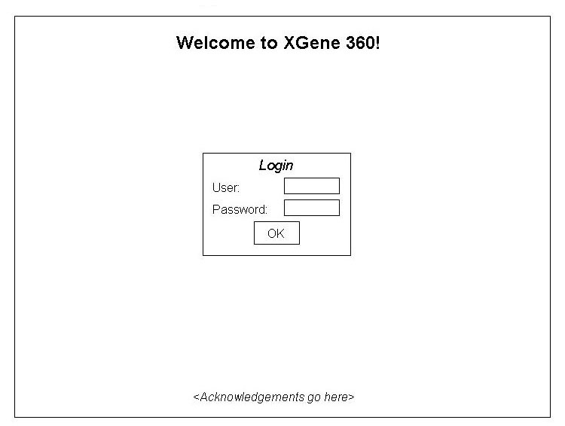
Figure 1: Login

Name | Login
Description | The first page a user sees. It will allow a user to login to the application.
Inputs | - Username  - Password
Outputs | The application accepts login information and brings the user to the corresponding starting page.
Possible Errors | An invalid login will result in a message indicating that the information is incorrect.

Name | Logout
Description | After the user clicks the logout button on any page, the user will see this page as verification of logoff.
Inputs | None
Outputs | The application accepts logout and sends user to corresponding page to show after logging off.
Possible Errors | None

Name | ChangePassword
Description | After the users clicks a link directing them to the page that allows them to change their password.
Possible Inputs | - New password
Outputs | The application accepts changed information and brings the user back to the previous page.
Possible Errors | An invalid field will result in a descriptive message indicating that the information is incorrect.

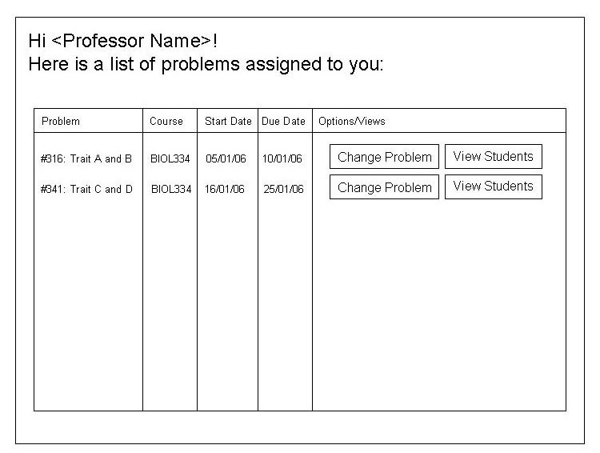
Figure 2: View Problems for Professor

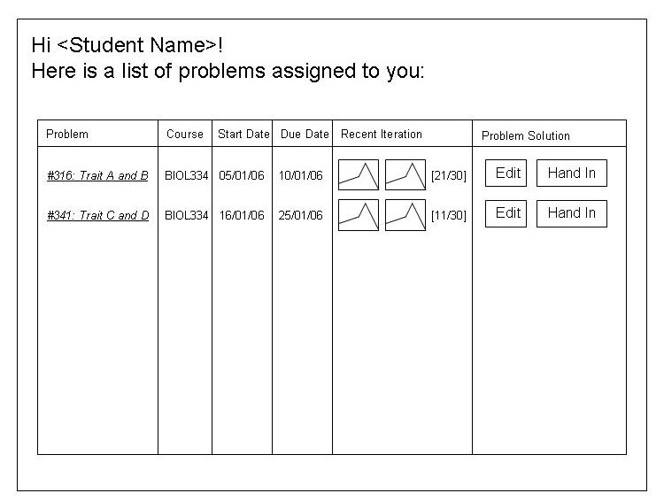
Figure 3: View Problems for Student

Name | ViewProblems
Description | Where a user can see a list of problems assigned/created by him/her. Details for the problem will be viewable via a button click. User-specific options will be available as well.
Inputs | None
Possible Outputs | Certain button clicks will bring you to the following possible pages:  - Changing problem parameters  - Viewing students and/or TAs assigned to problem  - Editing problem solution  - Handing in problem solution
Possible Errors | None

Name | ViewStudentProgress
Description | Where a user can see a student’s progress. Administrator, professors and TAs will be able to see the progress of all the students assigned to them.
Inputs | None
Outputs | None
Possible Errors | None

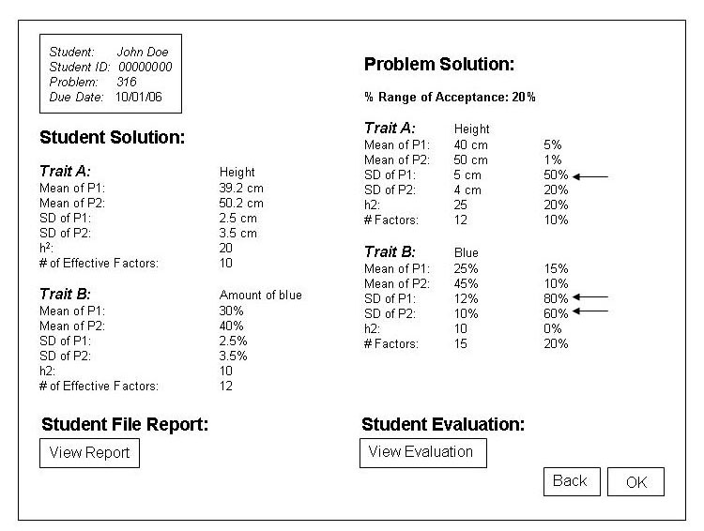
Figure 4: View Problem Solution

Name | ViewProblemSolution
Description | The user will be able to view student results for a problem as well as any feedback from the professor or TA.
Inputs | None
Outputs | None
Possible Errors | None

3.1.2 Administrator, Professor, TA Interfaces

Name | ViewCourses
Description | Where a user can see a list of courses. The modification page for a particular course will be viewable via a button click. Courses will be able to be deleted via a button click as well.
Inputs | None
Possible Outputs | For the administrator and professors, certain button clicks will bring you to the following possible pages:  - Modifying a course.  - Deleting a course.  TAs will not have any outputs.
Possible Errors | None

Name | ViewStudents
Description | Where a user can see a list of students assigned/created by him/her. The modification page for a particular student will be viewable via a button click. Students will be able to be deleted via a button click as well.
Inputs | None
Possible Outputs | For the administrator and professors, certain button clicks will bring you to the following possible pages:  - Modifying a student.  - Deleting a student.  TAs will not have any outputs.
Possible Errors | None

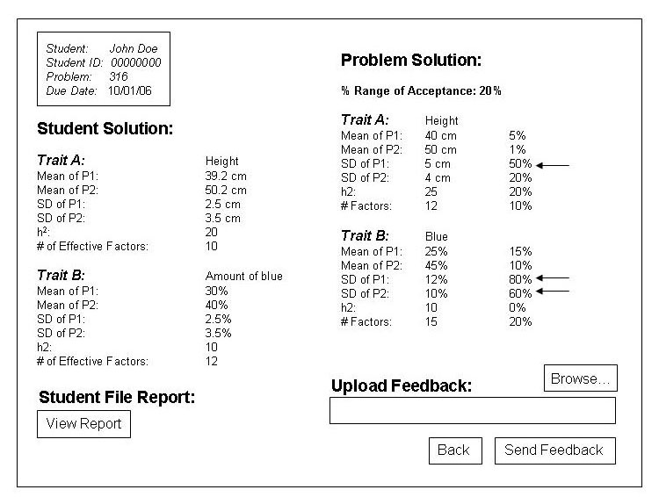
Figure 5: Evaluate Student

Name | EvaluateStudent
Description | The user will be able to view student results for a problem and upload an evaluation/feedback file.
Inputs | An evaluation/feedback file upload that will be optional.
Outputs | A page will pop up verifying the success of sending the evaluation.
Possible Errors | Evaluation file is invalid, so the application will output a message indicating that a valid file should be used.

3.1.3 Administrator, Professor Interfaces

Name | CreateProfessor
Description | Creates a new professor.
Inputs | - First name  - Last name  - Password
Outputs | After verifying the inputs, the application will output a username and password.
Possible Errors | Invalid information will result in a message indicating that the information is incorrect.

Name | DeleteProfessor
Description | Deletes an existing professor.
Inputs | None
Outputs | After verifying the existence of the professor account, the application deletes the account from the database and tells the user that deletion has been successful.
Possible Errors | Professor does not exist, and a message will appear indicating that the delete failed.

Name | ModifyProfessor
Description | Modifies an existing professor.
Inputs | New password
Outputs | A page will pop up verifying the modification.
Possible Errors | Password is invalid, so the application will output a message indicating that another password should be entered.

Name | CreateCourse
Description | Creates a new course.
Inputs | ID of course (i.e. BIOL121)
Outputs | After verifying the input, the application will output a message indicating success.
Possible Errors | Invalid/duplicate course will result in a error message.

Name | DeleteCourse
Description | Deletes an existing course.
Inputs | None
Outputs | After verifying the existence and information for the course, the application deletes the course from the database and tells the user that deletion has been successful.
Possible Errors | If the course is being used, the application will ask the user whether he/she is sure of deletion.

Name | ModifyCourse
Description | Modifies an existing course.
Inputs | New course ID
Outputs | A page will pop up verifying the modification.
Possible Errors | Input is invalid (i.e. duplicate), so the application will output a message indicating that valid input should be used.

Name | CreateTA
Description | Creates a new TA.
Inputs | - First name  - Last name  - Password  - Assigned courses (optional)
Outputs | After verifying the inputs, the application will output a username and password.
Possible Errors | Invalid information will result in a message indicating that the information is incorrect.

Name | DeleteTA
Description | Deletes an existing TA.
Inputs | None
Outputs | After verifying the existence of the TA account, the application deletes the account from the database and tells the user that deletion has been successful.
Possible Errors | TA does not exist, and a message will appear indicating that the delete failed.

Name | ModifyTA
Description | Modifies an existing professor.
Possible Inputs | - New password  - Assigned courses
Outputs | A page will pop up verifying the modification.
Possible Errors | Input is invalid, so the application will output a message indicating that valid input should be used.

Name | ViewTAs
Description | Where a user can see a list of TAs assigned/created by him/her. The modification page for a particular TA will be viewable via a button click. TAs will be able to be deleted via a button click as well.
Inputs | None
Possible Outputs | Certain button clicks will bring you to the following possible pages:  - Modifying a TA.  - Deleting a TA.
Possible Errors | None

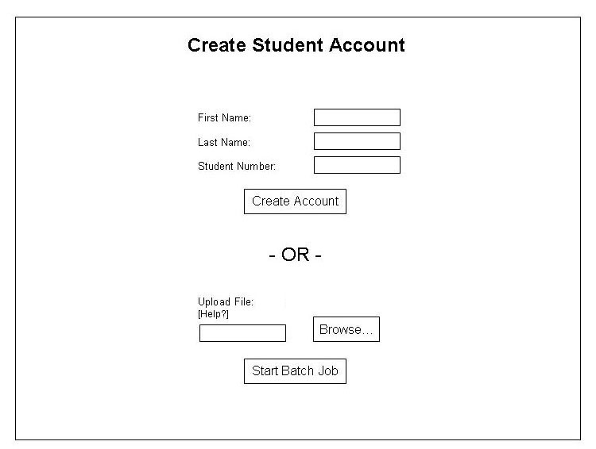
Figure 6: Create Student

Name | CreateStudent
Description | Creates a new student.
Inputs | - First name  - Last name  - Password  - Assigned courses (optional)  The user will also be able to upload a text file with a list of student information.
Outputs | After verifying the inputs, the application will output a username and password. If the user provided an excel sheet, then a list of usernames and passwords will be provided.
Possible Errors | Invalid information will result in a message indicating that the information is incorrect.

Name | DeleteStudent
Description | Deletes an existing student.
Inputs | None
Outputs | After verifying the existence of the student account, the application deletes the account from the database and tells the user that deletion has been successful.
Possible Errors | Student does not exist, and a message will appear indicating that the delete failed.

Name | ModifyStudent
Description | Modifies an existing student.
Possible Inputs | - New password  - Assigned courses
Outputs | A page will pop up verifying the modification.
Possible Errors | Input is invalid, so the application will output a message indicating that valid input should be used.

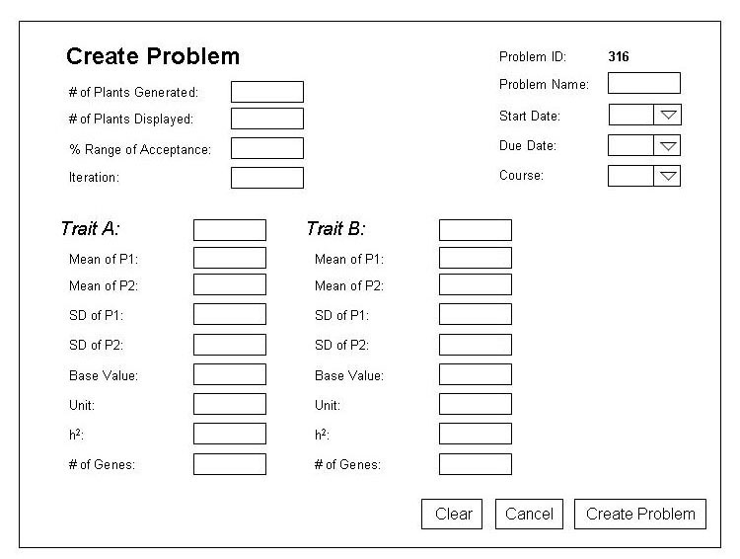
Figure 7: Create Problem

Name | CreateProblem
Description | Creates a new problem.
Inputs | Indicated by Figure 5.
Outputs | After verifying the input, the application will output a message indicating success.
Possible Errors | Invalid field inputs will result in an error message.

Name | DeleteProblem
Description | Deletes an existing problem.
Inputs | None
Outputs | After verifying information for the problem, the application deletes the problem from the database and tells the user that deletion has been successful.
Possible Errors | If the problem is being used, the application will ask the user whether he/she is sure of deletion.

Name | ModifyProblem
Description | Modifies an existing problem.
Inputs | Any of the inputs indicated by Figure 5 will be able to be modified.
Outputs | A page will pop up verifying the modification.
Possible Errors | Input is invalid (i.e. duplicate), so the application will output a message indicating that valid input should be used.

3.1.4 Administrator Interfaces

Name | CreateAdministrator
Description | Creates a new administrator. This only happens once in the application’s lifetime.
Inputs | - First name  - Last name  - Password
Outputs | After verifying the inputs, the application will output a username and password.
Possible Errors | Invalid information will result in a message indicating that the information is incorrect.

3.1.5 Student Interfaces

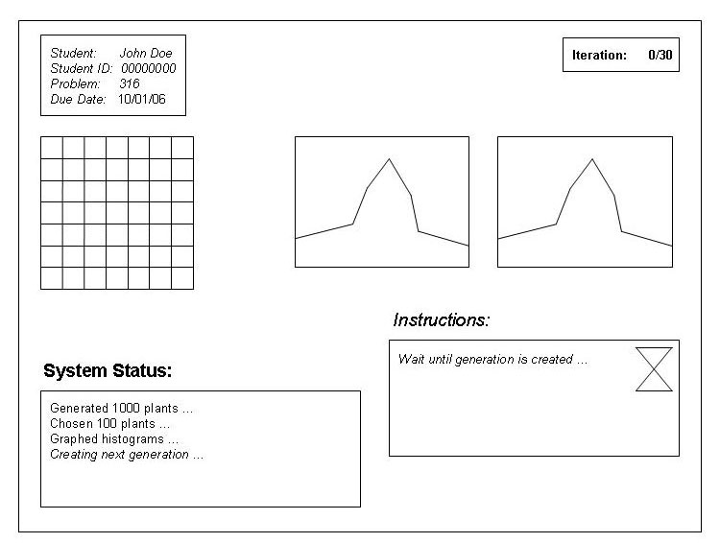
Figure 8: Begin Problem

Name | BeginProblem
Description | The user will start the problem and view the beginning problem parameters.
Inputs | None
Outputs | The next page in the problem will appear, allowing the student to continue.
Possible Errors | None

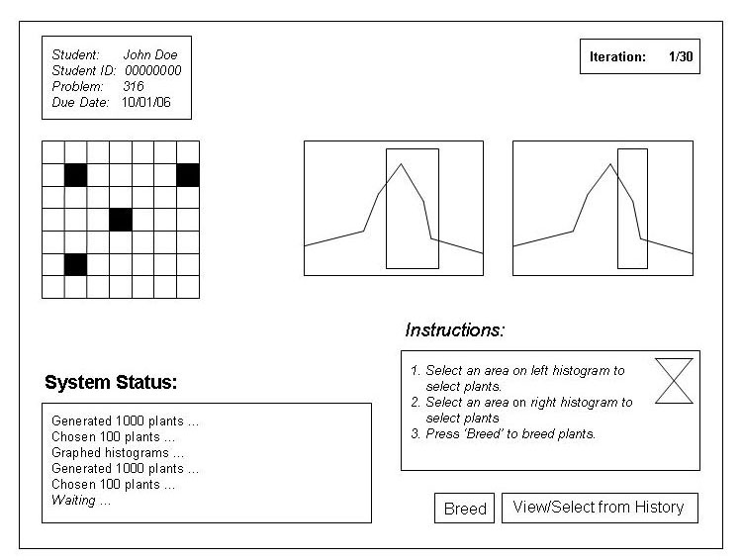
Figure 9: Breed Generation

Name | BreedGeneration
Description | Based on the current state of the problem, the user will be able to select plants for breeding.
Inputs | - An area in each histogram  - Seeds from the highlighted areas on the grid  - As an option, seeds from a previous generation
Outputs | Breeding will occur, and the next page in the problem will appear, allowing the student to continue.
Possible Errors | None

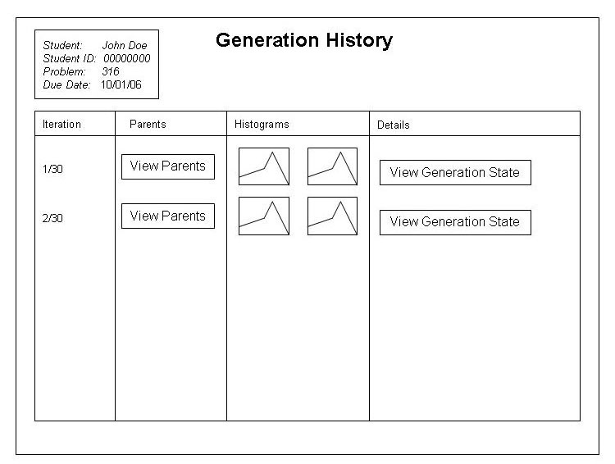
Figure 10: View Generation History

Name | ViewGenerationHistory
Description | The user will be able to view a generation history for the current problem.
Inputs | None
Outputs | Certain button clicks will bring you to the following possible pages:  - View the parents for the generation.  - View the problem state for that generation.
Possible Errors | None

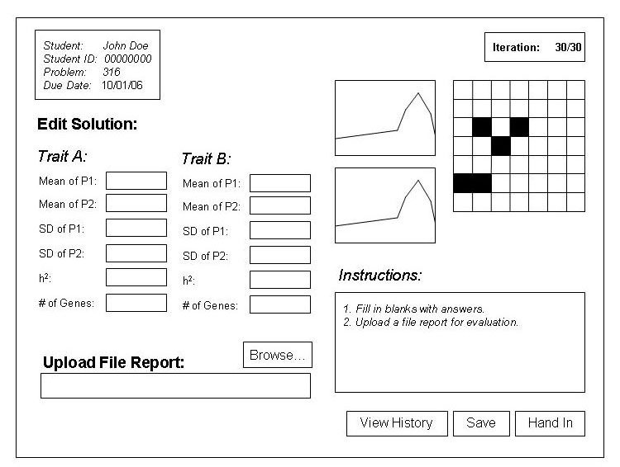
Figure 11: Edit Solution

Name | EditSolution
Description | The user will be able to evaluate the problem and hand in his/her solution.
Inputs | Indicated in Figure 10.
Outputs | Certain button clicks will bring you to the following possible pages:  - View the history for the problem.  - Save the problem solution.  - Hand in the problem solution.
Possible Errors | Fields and/or report file is invalid, so the application will output a message indicating that a valid input should be used.

3.2 Functions

3.2.1 Administrator, Professor, TA, Student Functions
Use case name | Login
Initiating actor | Administrator, Professor, TA, Student
Participating | None
Entry condition | The system has started.
Flow of events | - The initiating actor enters necessary fields.  - The initiating actor clicks the “Login” button.  - The system performs login authentication process.  - If the authentication is successful, the initiating actor is redirected to the homepage.  - If the authentication is unsuccessful, the initiating actor is redirected to the “Login” page with an error message indicating why the operation is unsuccessful.
Exit condition | The initiating actor is logged in and redirected to the homepage when the authentication is successful; otherwise, the initiating actor remains at the “Login” page.
Extension | None
Special requirements | None

Use case name | Logout
Initiating actor | Administrator, Professor, TA, Student
Participating | None
Entry condition | The initiating actor has logged in.
Flow of events | - The initiating actor selects “Logout”.  - The system performs the logoff process.  - The initiating actor is redirected to the login page.
Exit condition | The initiating actor is logged out.
Extension | None
Special requirements | None

Use case name | ChangePassword
Initiating actor | Administrator, Professor, TA, Student
Participating | None
Entry condition | The initiating actor has logged in.
Flow of events | - The initiating actor enters necessary fields.  - The initiating actor clicks the “Update” button.  - The system validates the inputs.  - If the inputs are valid, the system updates the information in the database and displays a message indicating the password has been successfully changed.  - If the inputs are invalid, the initiating actor is redirected back to the “Change Password” page with an error message indicating why the operation is unsuccessful.
Exit condition | The information is updated and is saved to the database when the inputs are valid; otherwise, the initiating actor remains at the “Change Password” page.
Extension | None
Special requirements | None

Use case name | ViewListOfProblems
Initiating actor | Administrator, Professor, TA, Student
Participating | None
Entry condition | The initiating actor has logged in.
Flow of events | - The initiating selects “View List of Problems”.  - The system finds all problems associated with the initiating actor.  - The list of problems is displayed.
Exit condition | The list of problems assigned to the initiating actor is displayed.
Extension | None
Special requirements | None

Use case name | SelectAProblem
Initiating actor | Administrator, Professor, TA, Student
Participating | None
Entry condition | The initiating actor has logged in and at least one problem can be selected.
Flow of events | - The initiating actor views the list of problems.  - The initiating actor selects a problem from the list.  - The initiating actor clicks “Select” button.
Exit condition | The selected problem is displayed.
Extension | None
Special requirements | None

3.2.2 Administrator, Professor Functions
Use case name | CreateProfessor
Initiating actor | Administrator, Professor
Participating | None
Entry condition | The initiating actor has logged in.
Flow of events | - The initiating actor selects “Create Professor”.  - The initiating actor enters necessary information.  - The initiating actor clicks “Create” button.  - The system validates the input.  - If the inputs are valid, the system updates the information in the database and displays a message indicating the account has been created.  - If the inputs are invalid, the initiating actor is redirected back to the “Create Professor” page with an error message indicating why the operation is unsuccessful.
Exit condition | The new account is created and is saved to the database when the inputs are valid; otherwise, the initiating actor remains at the “Create Professor” page.
Extension | None
Special requirements | None

Use case name | DeleteProfessor
Initiating actor | Administrator, Professor
Participating | None
Entry condition | The initiating actor has logged in.
Flow of events | - The initiating actor selects “Delete Professor”.  - The initiating actor selects a professor from the list to delete.  - The initiating actor clicks “Delete” button.  - The system tries to delete the account from the database.  - If the system successfully deletes the account, it displays a message indicating the account is successfully deleted.  - If the system fails to delete the account, the initiating actor is redirected back to the “Delete Professor” page with an error message indicating why the operation is unsuccessful.
Exit condition | The account is deleted from the database if the operation is successful; otherwise, the initiating actor remains at the “Delete Professor” page.
Extension | None
Special requirements | None

Use case name | ModifyProfessor
Initiating actor | Administrator, Professor
Participating | None
Entry condition | The initiating actor has logged in.
Flow of events | - The initiating actor selects “Modify Professor”.  - The initiating actor enters necessary information.  - The initiating actor clicks “Modify” button.  - The system validates the input.  - If the inputs are valid, the system updates the information in the database and displays a message indicating the information is successfully updated.  - If the inputs are invalid, the initial actor is redirected back to “Modify Professor” page with an error message indicating why the operation is unsuccessful.
Exit condition | The information is updated and is saved to the database when the inputs are valid; otherwise, the initiating actor remains at the “Modify Professor” page.
Extension | None
Special requirements | None

Use case name | CreateTA
Initiating actor | Administrator, Professor
Participating | None
Entry condition | The initiating actor has logged in.
Flow of events | - The initiating actor selects “Create TA”.  - The initiating actor enters necessary information.  - The initiating actor clicks “Create” button.  - The system validates the input.  - If the inputs are valid, the system updates the information in the database and displays a message indicating the account has been created.  - If the inputs are invalid, the initiating actor is redirected back to the “Create TA” page with an error message indicating why the operation is unsuccessful.
Exit condition | The new account is created and is saved to the database when the inputs are valid; otherwise, the initiating actor remains at the “Create TA” page.
Extension | None
Special requirements | None

Use case name | DeleteTA
Initiating actor | Administrator, Professor
Participating | None
Entry condition | The initiating actor has logged in.
Flow of events | - The initiating actor selects “Delete TA”.  - The initiating actor selects a TA to delete from the list.  - The initiating actor clicks “Delete” button.  - The system tries to delete the account from the database.  - If the system successfully deletes the account, it displays a message indicating the account is successfully deleted.  - If the system fails to delete the account, the initiating actor is redirected back to the “Delete TA” page with an error message indicating why the operation is unsuccessful.
Exit condition | The account is deleted from the database if the operation is successful; otherwise, the initiating actor remains at the “Delete TA” page.
Extension | None
Special requirements | None

Use case name | ModifyTA
Initiating actor | Administrator, Professor
Participating | None
Entry condition | The initiating actor has logged in.
Flow of events | - The initiating actor selects “Modify TA”.  - The initiating actor enters necessary information.  - The initiating actor clicks “Modify” button.  - The system validates the input.  - If the inputs are valid, the system updates the information in the database and displays a message indicating the information is successfully updated.  - If the inputs are invalid, the initial actor is redirected back to “Modify TA” page with an error message indicating why the operation is unsuccessful.
Exit condition | The information is updated and is saved to the database when the inputs are valid; otherwise, the initiating actor remains at the “Modify TA” page.
Extension | None
Special requirements | None

Use case name | CreateStudent
Initiating actor | Administrator, Professor
Participating | None
Entry condition | The initiating actor has logged in.
Flow of events | - The initiating actor selects “Create Student”.  - The initiating actor enters necessary information.  - The initiating actor clicks “Create” button.  - The system validates the input.  - If the inputs are valid, the system updates the information in the database and displays a message indicating the account has been created.  - If the inputs are invalid, the initiating actor is redirected back to the “Create Student” page with an error message indicating why the operation is unsuccessful.
Exit condition | The new account is created and saved to the database when the inputs are valid; otherwise, the initiating actor remains at the “Create Student” page.
Extension | None
Special requirements | None

Use case name | DeleteStudent
Initiating actor | Administrator, Professor
Participating | None
Entry condition | The initiating actor has logged in.
Flow of events | - The initiating actor selects “Delete Student”.  - The initiating actor selects a student to delete from the list.  - The initiating actor clicks “Delete” button.  - The system tries to delete the account from the database.  - If the system successfully deletes the account, it displays a message indicating the account is successfully deleted.  - If the system fails to delete the account, the initiating actor is redirected back to the “Delete Student” page with an error message indicating why the operation is unsuccessful.
Exit condition | The account is deleted from the database if the operation is successful; otherwise, the initiating actor remains at the “Delete Student” page.
Extension | None
Special requirements | None

Use case name | ModifyStudent
Initiating actor | Administrator, Professor
Participating | None
Entry condition | The initiating actor has logged in.
Flow of events | - The initiating actor selects “Modify Student”.  - The initiating actor enters necessary information.  - The initiating actor clicks “Modify” button.  - The system validates the input.  - If the inputs are valid, the system updates the information in the database and displays a message indicating the information is successfully updated.  - If the inputs are invalid, the initial actor is redirected back to “Modify TA” page with an error message indicating why the operation is unsuccessful.
Exit condition | The information is updated and is saved to the database when the inputs are valid; otherwise, the initiating actor remains at the “Modify Student” page.
Extension | None
Special requirements | None

Use case name | ImportStudents
Initiating actor | Administrator, Professor
Participating | None
Entry condition | The initiating actor has logged in.
Flow of events | - The initiating actor selects “Import Students”.  - The initiating actor selects a CSV file to be uploaded to the server for processing.  - The initiating actor clicks “Import” button.  - The system validates the file and reads information on each student.  - If the information is valid, the system creates an account for the student and saves the information to the database.  - If the information is invalid, the system skips creating an account for the student.  - If any account is skipped, the initiating actor is redirected back to “Import Students” page with an error message indicating why the operation is unsuccessful.
Exit condition | The new accounts have been added in the database when the information is valid; otherwise, the initiating actor remains at the “Import Students” page.
Extension | None
Special requirements | None

Use case name | CreateCourse
Initiating actor | Administrator, Professor
Participating | None
Entry condition | The initiating actor has logged in.
Flow of events | - The initiating actor selects “Create Course”.  - The initiating actor enters necessary information.  - The initiating actor clicks “Create” button.  - The system validates the input.  - If the inputs are valid, the system updates the information in the database and displays a message indicating the course has been created.  - If the inputs are invalid, the initiating actor is redirected back to the “Create Course” page with an error message indicating why the operation is unsuccessful.
Exit condition | The new course is created and saved to the database when the inputs are valid; otherwise, the initiating actor remains at the “Create Course” page.
Extension | None
Special requirements | None

Use case name | DeleteCourse
Initiating actor | Administrator, Professor
Participating | None
Entry condition | The initiating actor has logged in.
Flow of events | - The initiating actor selects “Delete Course”.  - The initiating actor selects a student to delete from the list.  - The initiating actor clicks “Delete” button.  - The system tries to delete the course from the database.  - If the system successfully deletes the course, it displays a message indicating the course is successfully deleted.  - If the system fails to delete the course, the initiating actor is redirected back to the “Delete Course” page with an error message indicating why the operation is unsuccessful.
Exit condition | The course is deleted from the database if the operation is successful; otherwise, the initiating actor remains at the “Delete Course” page.
Extension | None
Special requirements | None

Use case name | ModifyCourse
Initiating actor | Administrator, Professor
Participating | None
Entry condition | The initiating actor has logged in.
Flow of events | - The initiating actor selects “Modify Course”.  - The initiating actor enters necessary information.  - The initiating actor clicks “Modify” button.  - The system validates the input.  - If the inputs are valid, the system updates the information in the database and displays a message indicating the information is successfully updated.  - If the inputs are invalid, the initial actor is redirected back to “Modify Course” page with an error message indicating why the operation is unsuccessful.
Exit condition | The information is updated and is saved to the database when the inputs are valid; otherwise, the initiating actor remains at the “Modify Course” page.
Extension | None
Special requirements | None

Use case name | AssignStudentsToACourse
Initiating actor | Administrator, Professor
Participating | None
Entry condition | The initiating actor has logged in, at least one student can be selected, and at least one course can be selected.
Flow of events | - The initiating actor selects “Assign Students to Course”.  - The initiating actor selects list of students.  - The initiating actor selects a course.  - The initiating actor clicks “Add” button.  - The selected students are assigned to the selected course.
Exit condition | The students are assigned to the course.
Extension | None
Special requirements | None

Use case name | AssignStudentsToAProblem
Initiating actor | Administrator, Professor
Participating | None
Entry condition | The initiating actor has logged in, at least one student can be selected, and at least one problem can be selected.
Flow of events | - The initiating actor selects “Assign Students to Problem”.  - The initiating actor selects list of students.  - The initiating actor selects a problem.  - The initiating actor clicks “Add” button.  - The selected students are assigned to the selected problem.
Exit condition | The students are assigned to the problem.
Extension | None
Special requirements | None

Use case name | AssignProblemsToACourse
Initiating actor | Administrator, Professor
Participating | None
Entry condition | The initiating actor has logged in, at least one problem can be selected, and at least one course can be selected.
Flow of events | - The initiating actor selects “Assign Problem to Course”.  - The initiating actor selects list of problems.  - The initiating actor selects a course.  - The initiating actor clicks “Add” button.  - The selected courses are assigned to the selected course.
Exit condition | The problems are assigned to the course.
Extension | None
Special requirements | None

Use case name | RemoveStudentsFromCourses
Initiating actor | Administrator, Professor
Participating | None
Entry condition | The initiating actor has logged in, at least one course can be selected, and at least one student is assigned to that course.
Flow of events | - The initiating actor selects “View Student”.  - The initiating actor selects list of courses.  - The initiating actor clicks “Remove” button.  - The selected student is removed from the selected course.
Exit condition | The students are removed from the course.
Extension | None
Special requirements | None

Use case name | RemoveStudentsFromAProblem
Initiating actor | Administrator, Professor
Participating | None
Entry condition | The initiating actor has logged in, at least one problem can be selected, and at least one student is assigned to that problem.
Flow of events | - The initiating actor selects “View Student”.  - The initiating actor selects list of problems.  - The initiating actor clicks “Remove” button.  - The selected student is removed from the selected problem.
Exit condition | The students are removed from the problem.
Extension | None
Special requirements | None

Use case name | RemoveProblemsFromACourse
Initiating actor | Administrator, Professor
Participating | None
Entry condition | The initiating actor has logged in, at least one course can be selected, and at least one problem is assigned to that course.
Flow of events | - The initiating actor selects “View Course”.  - The initiating actor selects list of problems.  - The initiating actor clicks “Remove” button.  - The selected problems are removed from the selected course.
Exit condition | The problems are removed from the course.
Extension | None
Special requirements | None

Use case name | AssignTAsToACourse
Initiating actor | Administrator, Professor
Participating | None
Entry condition | The initiating actor has logged in, at least one TA can be selected, and at least one course can be selected.
Flow of events | - The initiating actor selects “Assign TAs to Course”.  - The initiating actor selects list of TAs.  - The initiating actor selects a course.  - The initiating actor clicks “Add” button.  - The selected TAs are assigned to the selected course.
Exit condition | The TAs are assigned to the course.
Extension | None
Special requirements | None

Use case name | AssignTAsToAProblem
Initiating actor | Administrator, Professor
Participating | None
Entry condition | The initiating actor has logged in, at least one TA can be selected, and at least one problem can be selected.
Flow of events | - The initiating actor selects “Assign TAs to Problem”.  - The initiating actor selects list of TAs.  - The initiating actor selects a problem.  - The initiating actor clicks “Add” button.  - The selected TAs are assigned to the selected problem.
Exit condition | The TAs are assigned to the problem.
Extension | None
Special requirements | None

Use case name | RemoveTAFromCourses
Initiating actor | Administrator, Professor
Participating | None
Entry condition | The initiating actor has logged in, at least one course can be selected, and at least one TA is assigned to that course.
Flow of events | - The initiating actor selects “View TA”.  - The initiating actor selects list of courses.  - The initiating actor clicks “Remove” button.  - The selected TA is removed from the selected course.
Exit condition | The TA is removed from the course.
Extension | None
Special requirements | None

Use case name | RemoveTAFromAProblem
Initiating actor | Administrator, Professor
Participating | None
Entry condition | The initiating actor has logged in, at least one problem can be selected, and at least one TA is assigned to that problem.
Flow of events | - The initiating actor selects “View TA”.  - The initiating actor selects list of problems.  - The initiating actor clicks “Remove” button.  - The selected TA is removed from the selected problem.
Exit condition | The TA is removed from the problem.
Extension | None
Special requirements | None

Use case name | CreateProblem
Initiating actor | Administrator, Professor
Participating | None
Entry condition | The initiating actor has logged in.
Flow of events | - The initiating actor selects “Create Problem”.  - The initiating actor enters necessary information.  - The actor clicks “Create” button.  - The system validates the input.  - If the inputs are valid, the system updates the information in the database and displays a message indicating the problem has been created.  - If the inputs are invalid, the initiating actor is redirected back to the “Create Problem” page with an error message indicating why the operation is unsuccessful.
Exit condition | The new problem is created and saved to the database when the inputs are valid; otherwise, the initiating actor remains at the “Create Problem” page.
Extension | None
Special requirements | None

Use case name | DeleteProblems
Initiating actor | Administrator, Professor
Participating | None
Entry condition | The initiating actor has logged in and at least one problem can be selected.
Flow of events | - The initiating actor selects “View List of Problems”.  - The initiating actor selects problems.  - The initiating actor clicks “Delete” button.  - The system tries to delete the problem from the database.  - If the system successfully deletes the problem, it displays a message indicating the problem is successfully deleted.  - If the system fails to delete the problem, the initiating actor is redirected back to the “Delete Problem” page with an error message indicating why the operation is unsuccessful.
Exit condition | The selected problems are removed from the database if the operation is successful; otherwise, the initiating actor remains at the “Delete Problem” page.
Extension | None
Special requirements | None

Use case name | ModifyProblem
Initiating actor | Administrator, Professor
Participating | None
Entry condition | The initiating actor has logged in and at least one problem can be selected.
Flow of events | - The initiating actor selects “View List of Problems”.  - The initiating actor selects a problem.  - The initiating actor clicks “Modify Problem” button.  - The initiating actor enters necessary information.  - The initiating actor clicks “Modify” button.  - The system validates the input.  - If the inputs are valid, the system updates the information in the database and displays a message indicating the information is successfully updated.  - If the inputs are invalid, the initial actor is redirected back to “Modify Problem” page with an error message indicating why the operation is unsuccessful.
Exit condition | The information is updated and is saved to the database when the inputs are valid; otherwise, the initiating actor remains at the “Modify Problem” page.
Extension | None
Special requirements | None

Use case name | CreateTrait
Initiating actor | Administrator, Professor
Participating | None
Entry condition | The initiating actor has logged in.
Flow of events | - The initiating actor selects “Create Trait”.  - The initiating actor enters necessary information.  - The initiating actor clicks “Create” button.  - The system validates the input.  - If the inputs are valid, the system updates the information in the database and displays a message indicating the trait has been created.  - If the inputs are invalid, the initiating actor is redirected back to the “Create Trait” page with an error message indicating why the operation is unsuccessful.
Exit condition | The new trait is created and saved to the database when the inputs are valid; otherwise, the initiating actor remains at the “Create Trait” page.
Extension | None
Special requirements | None

Use case name | DeleteTrait
Initiating actor | Administrator, Professor
Participating | None
Entry condition | The initiating actor has logged in.
Flow of events | - The initiating actor selects “Delete Trait”.  - The initiating actor selects a trait to delete from the list.  - The initiating actor clicks “Delete” button.  - The system tries to delete the trait from the database.  - If the system successfully deletes the trait, it displays a message indicating the problem is successfully deleted.  - If the system fails to delete the trait, the initiating actor is redirected back to the “Delete Trait” page with an error message indicating why the operation is unsuccessful.
Exit condition | The trait is deleted from the database if the operation is successful; otherwise, the initiating actor remains at the “Delete Trait” page.
Extension | None
Special requirements | None

Use case name | ModifyTrait
Initiating actor | Administrator, Professor
Participating | None
Entry condition | The initiating actor has logged in.
Flow of events | - The initiating actor selects “Modify Trait”.  - The initiating actor enters necessary information.  - The initiating actor clicks “Modify” button.  - The system validates the input.  - If the inputs are valid, the system updates the information in the database and displays a message indicating the information is successfully updated.  - If the inputs are invalid, the initial actor is redirected back to “Modify Trait” page with an error message indicating why the operation is unsuccessful.
Exit condition | The information is updated and saved to the database when the inputs are valid; otherwise, the initiating actor remains at the “Modify Trait” page.
Extension | None
Special requirements | None

Use case name | ExportPastCourseData
Initiating actor | Administrator, Professor
Participating | None
Entry condition | The initiating actor has logged in.
Flow of events | - The initiating actor selects “Export Past Course Data”.  - The initiating actor selects courses from the list of courses.  - The initiating actor clicks “Export” button.  - The initiating actor selects where the file is saved to.
Exit condition | The selected course data is saved to the path the initiating actor selects.
Extension | None
Special requirements | None

e case name | RemovePastCourseData
Initiating actor | Administrator, Professor
Participating | None
Entry condition | The initiating actor has logged in.
Flow of events | - The initiating actor clicks “Remove Past Course Data”.  - The initiating actor selects courses from the list of courses..  - The initiating actor clicks “Remove” button.
Exit condition | The selected course data is removed from the database.
Extension | None
Special requirements | None

3.2.3 Administrator, Professor, TA Functions
Use case name | ViewListOfStudentsAssignedToACourse
Initiating actor | Administrator, Professor, TA
Participating | None
Entry condition | The initiating actor has logged in and at least one course can be selected.
Flow of events | - The initiating actor selects a course from the list.  - The initiating actor selects “View List of Students”.  - The system finds all students assigned to the course.  - The list of students is displayed.
Exit condition | The list of students assigned to the course is displayed.
Extension | None
Special requirements | None

Use case name | ViewListOfStudentsAssignedToAProblem
Initiating actor | Administrator, Professor, TA
Participating | None
Entry condition | The initiating actor has logged in and at least one problem can be selected.
Flow of events | - The initiating actor selects a problem from the list.  - The initiating actor selects “View List of Students”.  - The system finds all students assigned to the problem.  - The list of students is displayed.
Exit condition | The list of students assigned to the problem is displayed.
Extension | None
Special requirements | None

Use case name | ViewStudentProgress
Initiating actor | Administrator, Professor, TA
Participating | None
Entry condition | The initiating actor has logged in.
Flow of events | - The initiating actor selects a student.  - The initiating actor selects a problem.  - The initiating actor clicks “View Progress” button.  - The system finds the information of the student and the problem.
Exit condition | The progress of the student is displayed.
Extension | None
Special requirements | None

Use case name | ViewStudentAnswer
Initiating actor | Administrator, Professor, TA
Participating | None
Entry condition | The initiating actor has logged in and at least one student has submitted the answer.
Flow of events | - The initiating actor selects “View Student”.  - The initiating actor selects “View List of Problems”.  - The initiating actor selects “View Answer”.
Exit condition | The answer submitted by the student is displayed.
Extension | None
Special requirements | None

Use case name | SendFeedback
Initiating actor | Administrator, Professor, TA
Participating | None
Entry condition | The initiating actor has logged in and at least one student has submitted the answer.
Flow of events | - The initiating actor selects “View Student Answer”.  - The initiating actor enters necessary information.  - The initiating actor clicks “Send Feedback” button.  - The system validates the input.  - If the inputs are valid, the system updates the information in the database and displays a message indicating the feedback has been saved.  - If the inputs are invalid, the initial actor is redirected back to “Send Feedback” page with an error message indicating why the operation is unsuccessful.
Exit condition | The information is updated and saved to the database when the inputs are valid; otherwise, the initiating actor remains at the “Send Feedback” page.
Extension | None
Special requirements | None

3.2.4 Student Functions
Use case name | ViewListOfGenerations
Initiating actor | Student
Participating | None
Entry condition | The initiating actor has logged in and has selected a problem.
Flow of events | 1. The initiating actor views the list of generation created for the problem.
Exit condition | List of generations created for the problem is displayed.
Extension | None
Special requirements | None

Use case name | SelectGeneration
Initiating actor | Student
Participating | None
Entry condition | The initiating actor has logged in and has selected a problem.
Flow of events | - The initiating actor views the list of generations for the selected problem.  - The initiating actor selects a generation to view.
Exit condition | The generation is displayed.
Extension | None
Special requirements | None

Use case name | SelectGeneDistribution
Initiating actor | Student
Participating | None
Entry condition | The initiating actor has logged in, has selected a problem, and has selected a generation.
Flow of events | - The initiating actor selects a distribution partition from the histogram.
Exit condition | Plants belong to that distribution is highlighted.
Extension | None
Special requirements | None

Use case name | SelectParentPlant
Initiating actor | Student
Participating | None
Entry condition | The initiating actor has logged in and a problem is selected.
Flow of events | - The initiating actor selects target plants from the list of plants displayed.
Exit condition | Selected plants are marked as parent plants.
Extension | None
Special requirements | None

Use case name | CrossPlants
Initiating actor | Student
Participating | None
Entry condition | The initiating actor has logged in, has selected a problem, and has selected the parent plants.
Flow of events | - The initiating actor clicks “Cross” button.  - The system performs crossing process.  - If the process is successful, the initiating actor is redirected to “List of Generation” page.  - If the process is unsuccessful, the initiating actor is redirected to the “Cross Plant” page with an error message indicating why the operation is unsuccessful.
Exit Condition | The system generates new generation when the crossing process is successfully performed; otherwise, the user remains at the “Cross Plant” page.
Extensions | None
Special requirements | None

Use case name | SubmitAnswer
Initiating actor | Student
Participating | None
Entry condition | The initiating actor has logged in and has selected a problem.
Flow of events | - The initiating actor enters necessary information.  - The initiating actor clicks “Submit” button.  - The system validates the input.  - If the inputs are valid, the system saves the information to the database and displays a message indicating the answer has been submitted.  - If the inputs are invalid, the initiating actor is redirected back to the “Submit Answer” page with an error message indicating why the operation is unsuccessful.
Exit condition | The answer is submitted and saved to the database when the inputs are valid; otherwise, the initiating actor remains at the “Submit Answer” page.
Extension | None
Special requirements | None

3.3 Performance Requirements
The number of concurrent users and requests per second will be ultimately determined by the physical resources (RAM, disk space, processor speed) of the application server on which the application will be installed as well as the geographic location of the server and its connected internet connection performance.

On the assumptions that the server will be located on campus, the majority of clients will access the server on campus or within a general vicinity of the campus, and the server specifications outlined in section 2.4.1, an estimated average of five requests per second will be handled without affecting the responsiveness of the system.

Disk space requirements will be met in order for the system to function properly. The system will use an estimated 30 megabytes within the MySQL server with per class with specifications of 300 students, 100 plants, 64 genes and 50 crosses. The estimate will increase or decrease and is dependant on the specifications given to a problem as well as class sizes. Each request to the server will indirectly imply one or more operations to the database.

3.4 Logical Database Requirements
All the information stored in the database will be accessed and modified only through the web-based user interface provided by the software.

A student will be assigned to a course or a problem. The administrator will have an option to assign a problem to a course without assigning all students participating in that course being assigned to that problem.

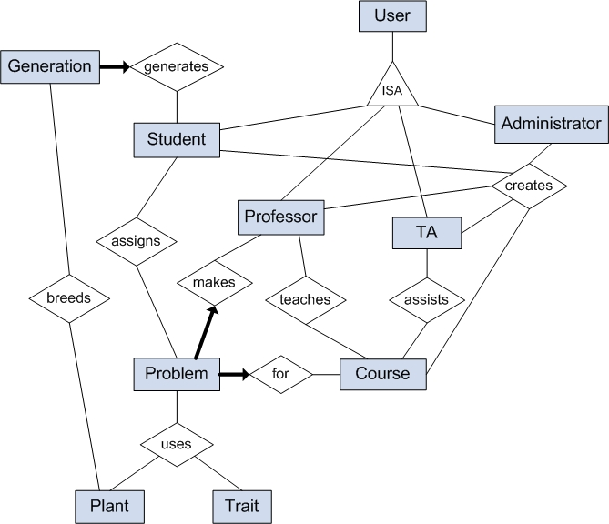

Figure 12: ER Diagram

3.5 Software System Attributes

3.5.1 Reliability
If an error occurs and forces the application to terminate, an error log will be generated in order to trace back to the origin and cause of the error.

3.5.2 Availability
The application will be available online at all times. Access to the application will be through a URL address. It will be assumed that the application will run on the administrator’s server, so the actual availability will depend on the server’s availability.

Data recovery will be handled by the application’s database server. In the case of a server restart, the application will have to be restarted by the administrator unless it is manually specified to run upon server restart.

3.5.3 Security
The database files containing administrator, professor, TA and student data will not be directly accessible by any of the four under any circumstances.

The administrator, professors, TAs, and students will require a password to enter the system online. The administrator will have the highest level of access, which includes the ability to assign user information (username, password) to any professor, TA or student. Professors will be able to assign user information to a professor, TA or student. Passwords will not be encrypted since permission to change or reset passwords will be limited.

Any errors in the application will be logged in a file with timestamps.

3.5.4 Maintainability
Maintenance will be minimal and mainly consist of any backup and repair done by the administrator. The administrator and professors will be allowed the optional action of removing past course data. Past course data will contain problem parameters and student interactions in the system.

3.5.5 Portability
This application will be written in PHP, which is a cross-platform language that allows portability. It also will need a MySQL database server for the storing of student information and transactions. Specifically, it will be able to run on a Mac UNIX platform server. The application will work with browsers that support HTML 4.0 and CSS 1.0.

4. Change Management Process
For any changes requested, either by the client, instructor, or other team members, the following process must be followed:

- Any requests for change will be presented as a hard-copy request containing a detailed description of the change. This hard-copy can be made by either the person requesting the change or any member of the team who is present at the time of the request.
- This hard-copy request will be presented to the risks manager who will assess the impact of implementing the request.
- If the request does not hinder other functions of the program, then the request will be passed to the progress manager. The progress manager will assess the feasibility of including the request with the implementation on the current timeline.
- Finally, if the request is feasible on the current timeline, then the request will be presented to the project manager for final approval.
- If necessary, the contact manager will notify the person requesting the status of the request.

5. Document Approvals
By signing in the space provided below, I hereby agree to adhere to the requirements and specifications outlined in this document.

_________________________
Client’s Name

_________________________
Signature

_________________________
Date

_________________________
Team Lead

_________________________
Signature

_________________________
Date

6. Supporting Information

6.1 Client Proposal

Expansion of ‘Greengene’, an Interactive Web-based Plant Breeding Simulation, to Simulate Quantitative Genetics

Facility: UBC Botanical Garden and Centre for Plant Research
Faculty of Land and Food Systems
323 Macmillan Building
UBC

Client: Dr. Andrew Riseman (ariseman@interchange.ubc.ca)

Introduction:
Greengene is simulation software used to introduce students to some of the concepts relevant to plant breeding and sexual reproduction. Specifically, the program is currently designed to simulate qualitative genetics with respect to dominance (i.e. intra-allelic interaction) where outcomes are based on either no dominance or dominance, linkage (i.e. inter-allelic interaction) where segregation between 2 traits is not random (i.e. not equal proportions of each trait in subsequent generations), and epistasis (i.e. inter-loci interaction) where the interaction of 2 genes affect the expression of a single trait, either with altered ratios or the expression of a new phenotype not observed in the parents.

Currently, Greengene is written in an open-source language and runs as a cross platform server application. I would like to expand Greengene’s capacity by including a simulation of quantitative genetics.

Current Program Description:
Each student is given a unique and individual problem (i.e., addressing only qualitative genetics), from which Greengene produces progeny and subsequent generations through adhering to pre-set instructor parameters specific to that student. These parameters are unknown to the student and are, in fact, the objective of the exercise; to determine dominance relationships within a trait, to identify genetic distances between traits, and to identify the presence and form of epistasis.

Greengene currently allows for the manipulation of three traits (through the effects of potentially four genes if epistasis in engaged) simultaneously, acting independently or together, as set-up in the instructor’s parameters. For example, Trait 1, Plant Height, may have the phenotypes short, intermediate, or tall. Trait 2, Disease Resistance, may have resistant, moderate, or susceptible as the phenotypes. Trait 3, Flower Color, may have the phenotypes, white, pink, or red for any individual (i.e. a virtual plant within a progeny). Trait 4 may act as an epistatic gene to Trait 3 where Flower Color is affected and expressed as altered ratios or new phenotypes, depending on the allelic configuration of the progeny. Any individual will possess only one phenotype of each of the three traits. Therefore, individual 1 could be tall (Trait 1), moderate (Trait 2), and white (Trait 3) while individual 2 may be short, susceptible, and red. The number of phenotypes is determined based on the dominance parameter and the presence/absence of epistatis. If Trait 1 has dominance (w/o epistasis), only 2 forms can be produced, red or white. If no dominance is present, all 3 forms are possible.

Initially, a student is assigned a ‘crop’ and given the 1st 50 progeny from a self-pollination of an initial plant created based on the instructor’s parameter inputs. The instructor generates this 1st progeny group. The students then need to make a series of virtual crosses from this population to generate subsequent generations. Based on analyses of the resulting progenies, the student is able to determine the dominance relationships within a trait, determine linkage distances between any 2 traits, and identify the presence and type of epistasis.

New Code Description
Quantitative Genetics: This enhancement should enable a separate (i.e., non-qualitative) problem for student access. It will simulate the function of two independent (i.e., non-linked) traits via the action of multiple genes (i.e., quantitative genetics). Problem set-up should involve inputting the trait descriptions (i.e., yield, disease resistance), the number of effective factors for each trait (i.e., number of genes), parent #1 mean values, parent #2 mean values, variance values for selected populations, and heritability values. Additional information on quantitative genetics, variance calculations, and heritability calculations are available upon request.

Further details will evolve from client meetings.

Non-Functional Requirements:
I. The new code is designed to enhance the functionality of Greengene in the teaching of plant genetics.
A. The new code will be minimally integrated into the existing code only when needed.
B. The new function will be used by teachers to setup quantitative genetics problems for students, and be used by students to simulate quantitative genetics in plants.
C. The genetics logic will come from new code.
D. The program is protected by passwords and the new code should continue to use them.
E. The program will be accessed through a web interface.
F. The program will have built-in Help screens detailing to procedures associated with any particular activity.

Further Information:
- Write for Linux server only
- Prefer no Java or compiled code but is acceptable as long as #8-13 below are fulfilled.
- Continue use of the interpreted language used to write Greengene
- Can be database or flat files
- Must install and run on our server, a Mac G4.
- Error log capable (messages either added to log or displayed on screen)
- Install instructions need very high degree of detail
- For demonstration, passing grade is based on successful installation on our machine
- All groups must install sequentially without moving other programs; must create own directory
- Self-installing/extracting Zipped file
- All groups must use common software (only one machine)
- No dedicated IT support; must be drop and install.

6.2 Sample Lecture Slides (Quantitative Genetics)

(Permission given by the client)
